BlinQ Exercise – Trainer Copy
[Instructions: Please use this document to guide your group in completing the task]

- Creating an Appointment & Customer
- Your customer’s name is Tian, and he is looking to fit fauxwood blinds in his window. You schedule an appointment with him on Friday, 04/04/2025 at 1500-1600 Hrs. Enter his details below to create a customer on the calendar tab:
- [Tian’s details]
- Press the calendar icon to navigate to the appointments page
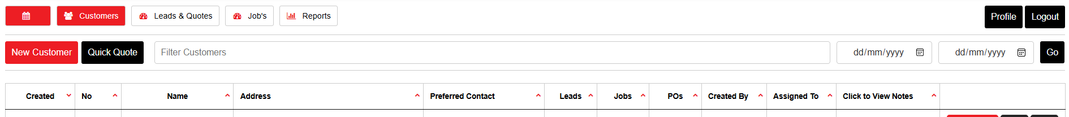

- Press the cell under 3pm on the specified date to open a customer detail page
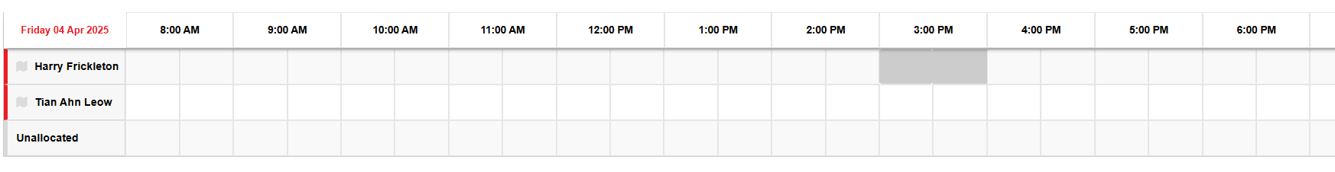

- Fill in the first column with the following details. Then, press the ‘Get Default Job Details’ Button on top to copy the information over to the second column and save time:
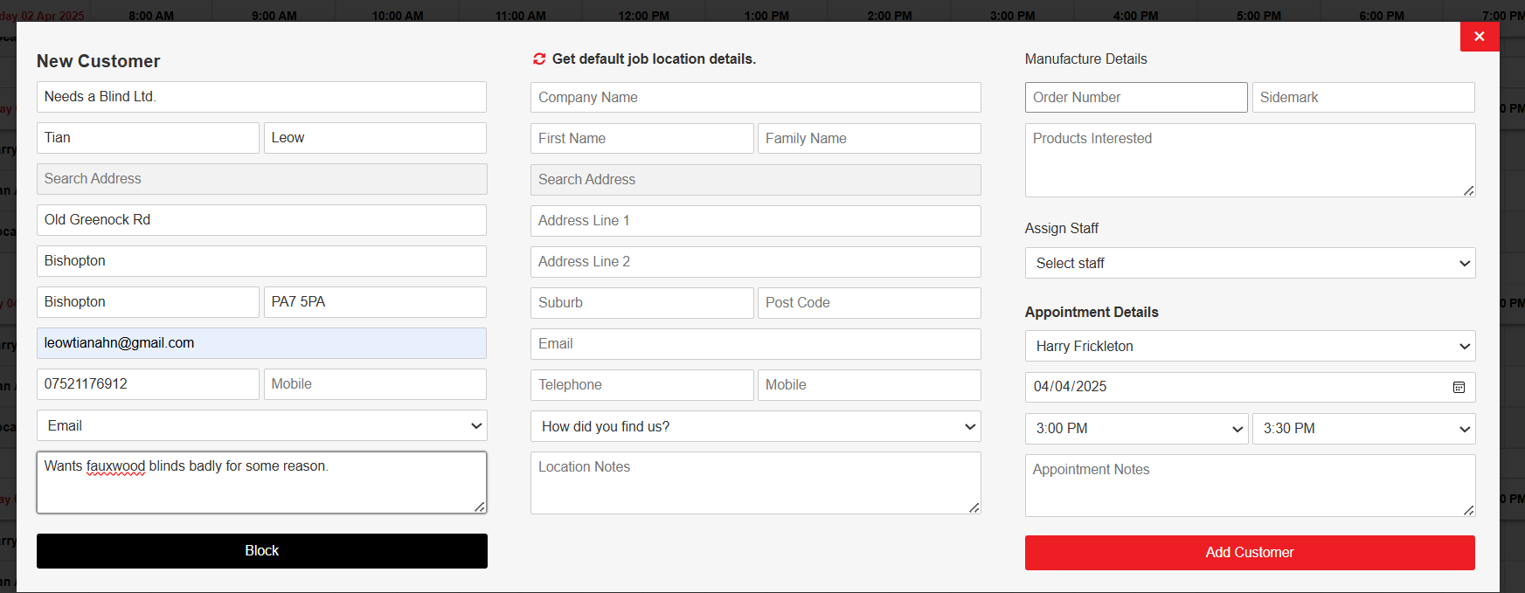

- Finalise the customer details by pressing the ‘add customer’ button
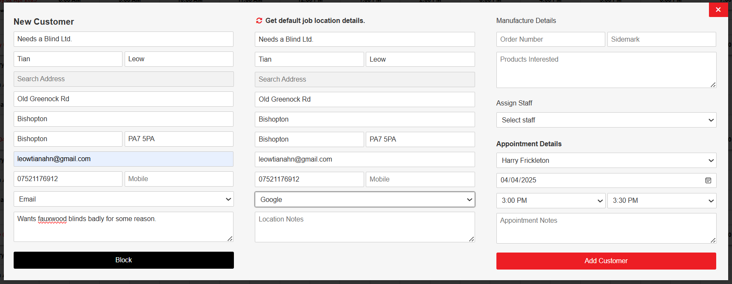
- Once that’s complete the appointment will be created – click on the appointment and press the resulting ‘Open Quote’ button to quickly navigate to the quotes page.
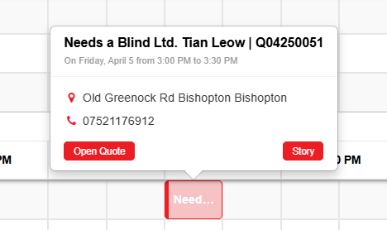

- Creating a Quote (Fauxwood Blinds)
- You get to Tian’s house and find him oddly enthusiastic about fauxwood blinds. You take the measurements of his window and pass him the Wood Collection. He selects his colour and want’s the blind installed to the following specs:
- [Blind Specifications]
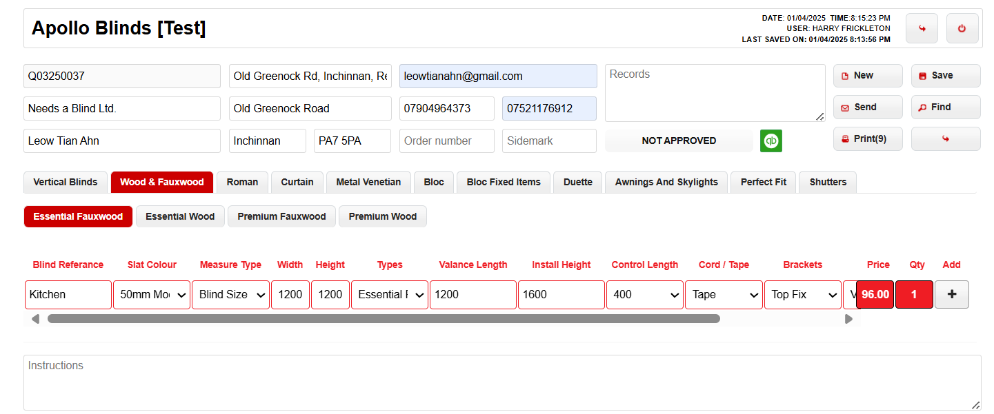Draw up a quote for him!

- Creating more Blinds using the Copy Function
- Tian really loves fauxwood. He wants another three of exactly the same blind for a total of 4 fauxwood blinds. Add these to the quote. (Hint: Try using the Copy function)
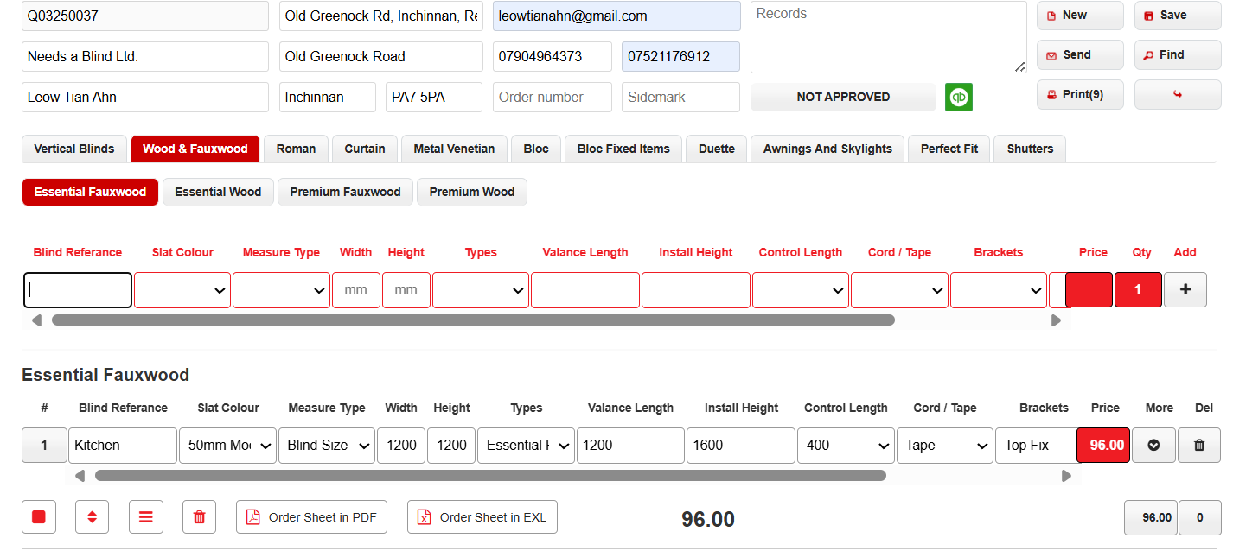

Click the Number 1, then press the Copy Selection button.
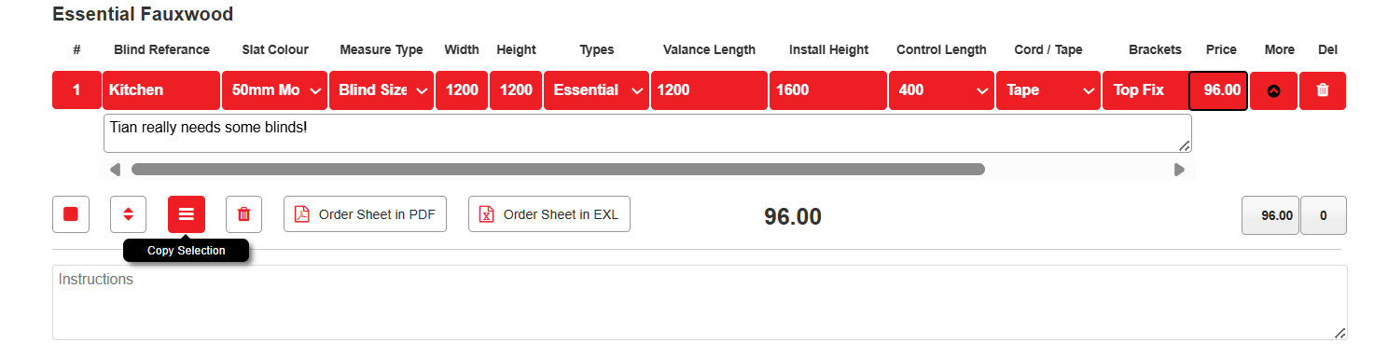

You will now have 2 line items, press the Copy Selection button again and you should have four line items.
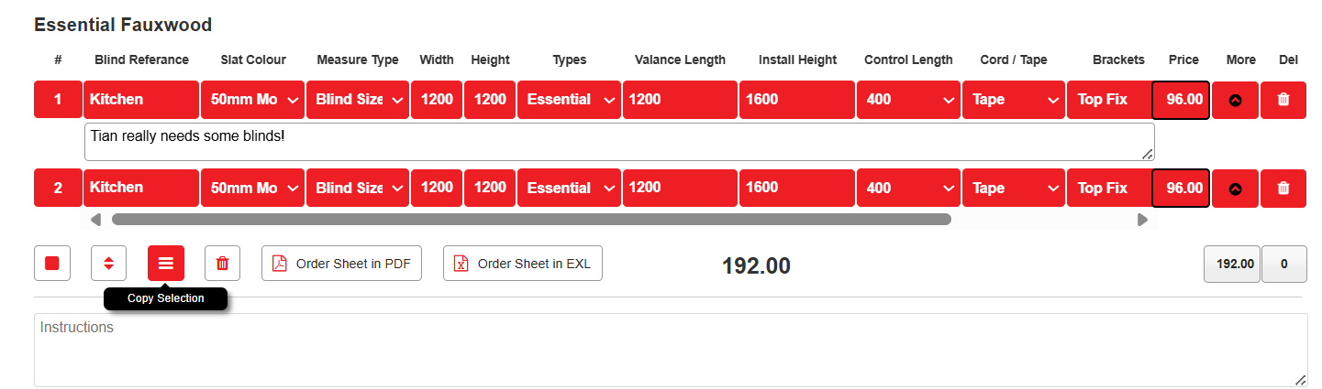
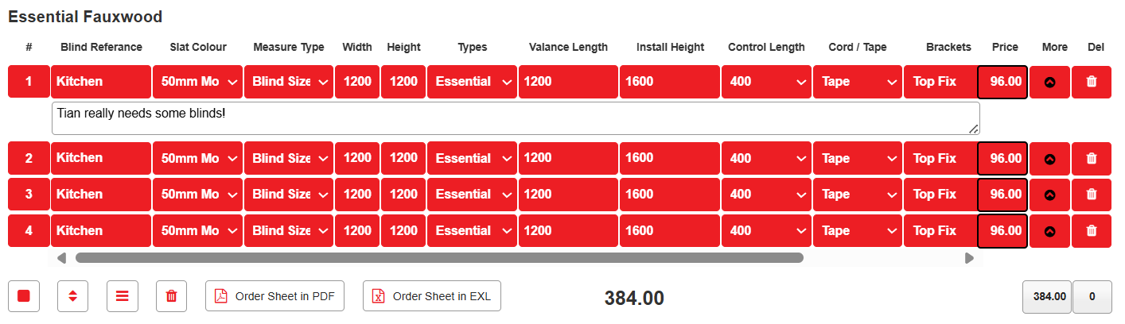
- Adding a discount to the quote

- Tian is a little broke and you’re feeling extra kind today and offer him a 10% discount off the full retail price of the blinds. Add the discount tot the quote:
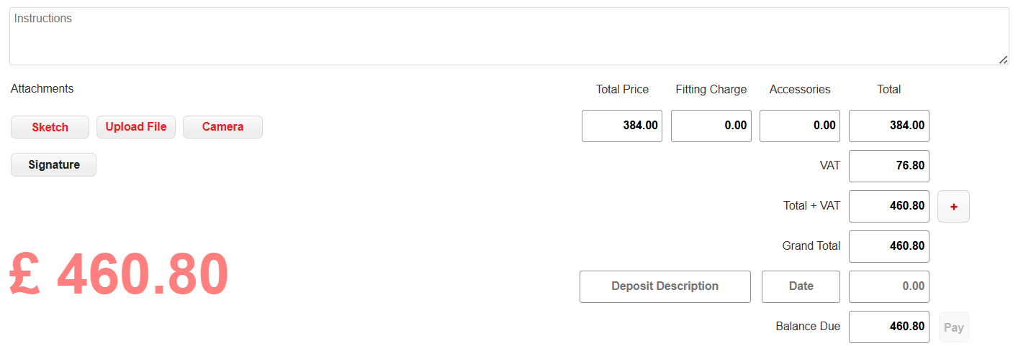
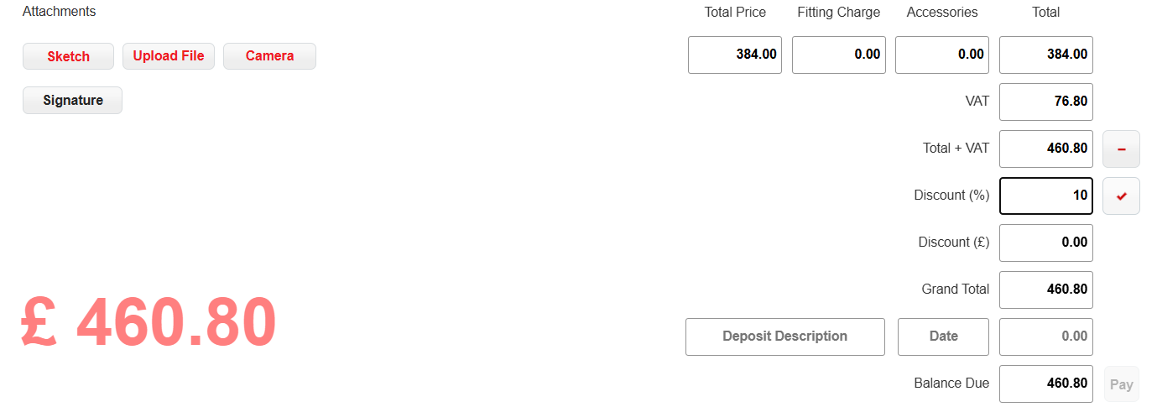
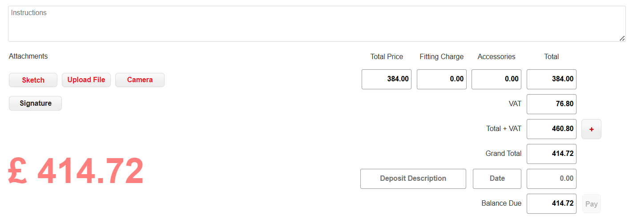

- Signature Collection & Quote Approval

Tian is happy with the quote. Collect his signature and approve the quote.
- Step 1: Press the Signature button and obtain the customer’s signature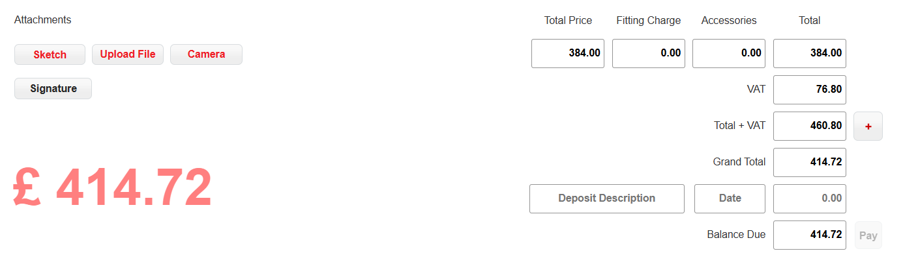
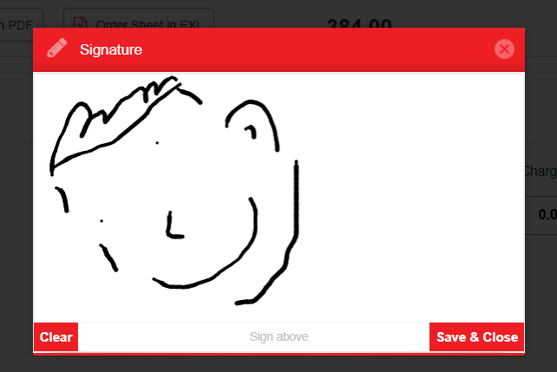
Once his signature is collected it should show up on the quote page.
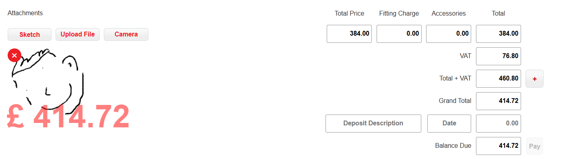

- Step 2: Approve the quote by scrolling to the top of the page and pressing the grey ‘Not Approved’ Button. It should turn red and say ‘Approved’
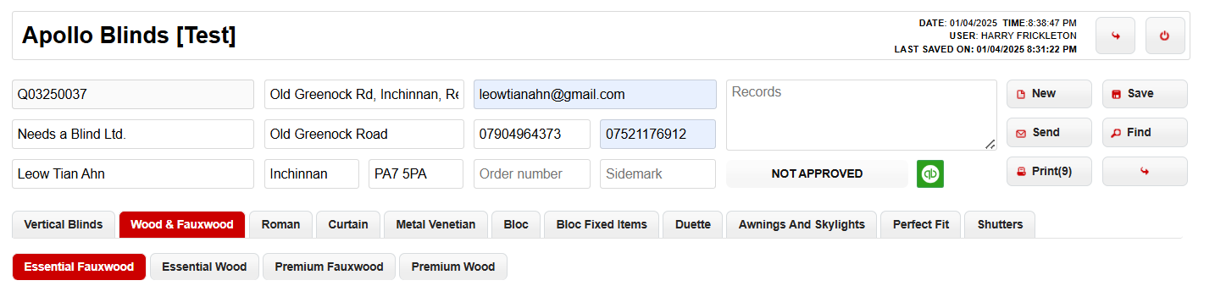
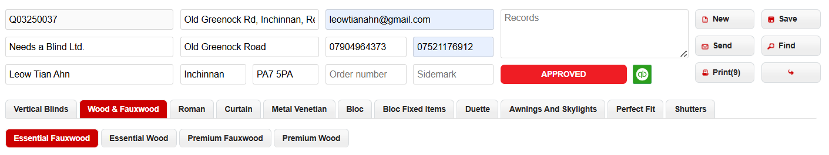
[Trainers please point out that once the quote is approved franchisees can no longer amend the price of the order as the ‘Type’ field will be locked- so be sure to obtain a signature before this step.]

- Placing an order

You’re ready to go ahead and order the blind. Press the back button on the quote page and return to the main BlinQ interface

- Navigate to the Job’s tab at the top left of the page
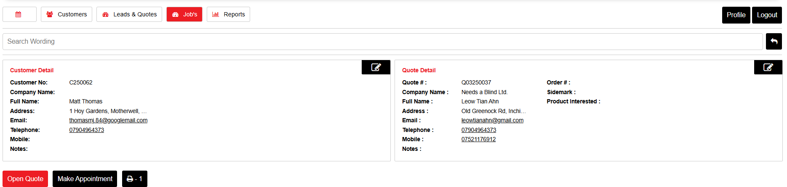

- Find the quote you have just approved {[Hint: You can refer to the unique job number starting a J]
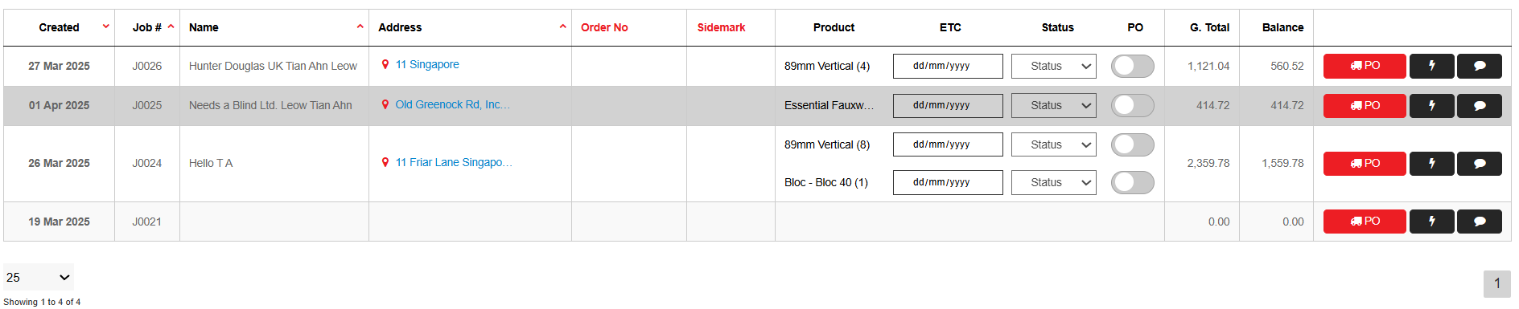

- Press the toggle to send the PO to Apollo Head Office for your order to be processed [Tip: If the customer has ordered different types of products there will be more than one toggle – to ensure your order has been sent make sure all of them have been selected]
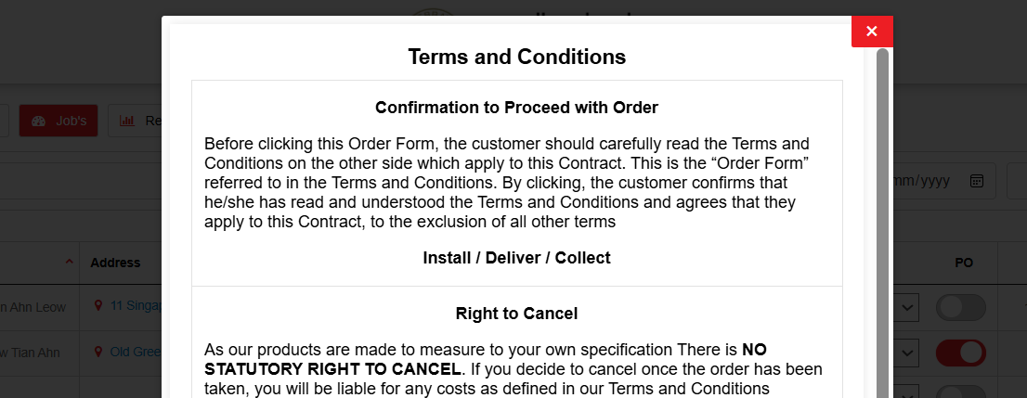

- Read the terms and conditions and accept the bottom of the page:
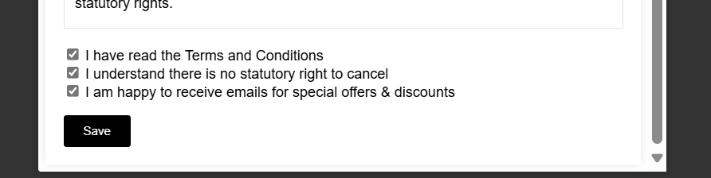
- Once you press the send button you will be brought to a dialogue box – for today please indicate for this test to be ignored. This email will be received by Apollo HO for your order to be processed.
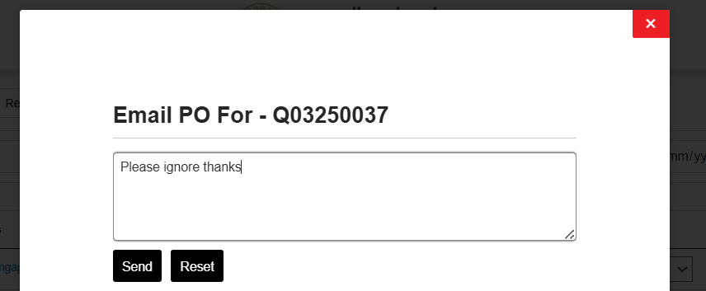

- Activity Complete

You have now completed this activity. Please note the toggle has now become red to indicate that your order has been sent.
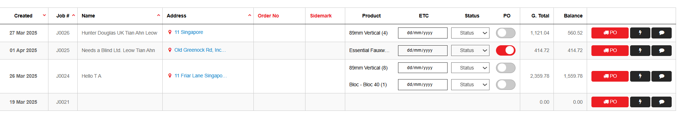
- The office will now update the status of your job in the adjacent box. It will indicate the estimated date of delivery for you to plan your installation.

